Task No 01: Perform the following task on the Excel sheet provided given below by using the built-in functions.
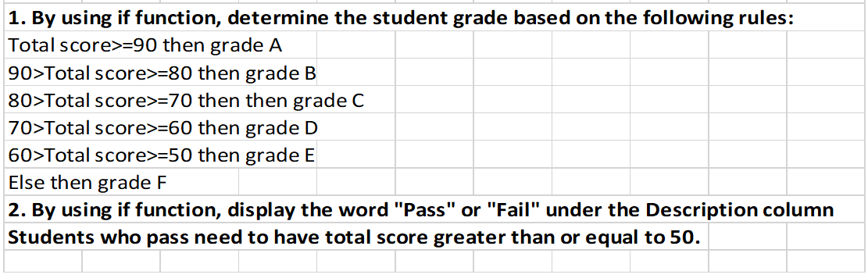

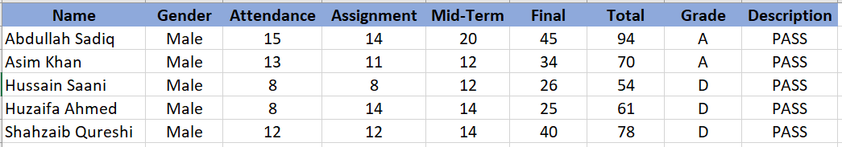

Task No 02: Perform the following task on the Excel sheet provided given below for performing the given task in this lab.
- Insert a Pivot Table for the given data.

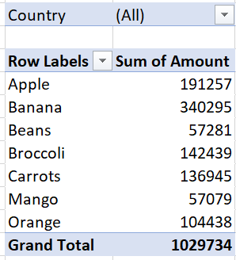

- Find out which products do we export the most to USA?

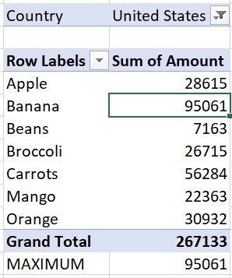

- Find the summary calculation "Maximum" and save the results.

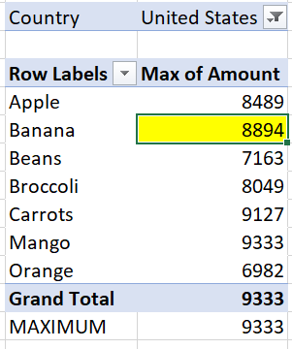

- Construct a 2-dimensional Pivot Table.

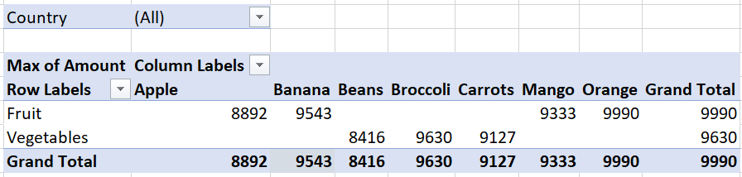

- Insert the pivot Chart for 2-dimensional Pivot Table.
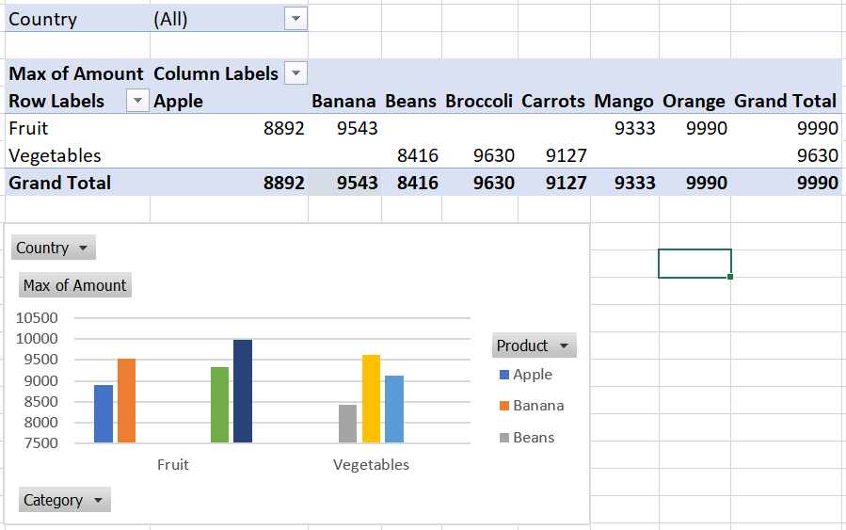

- Use the country filter that only show the total amount of each product exported to the Canada in Pivot Chart.

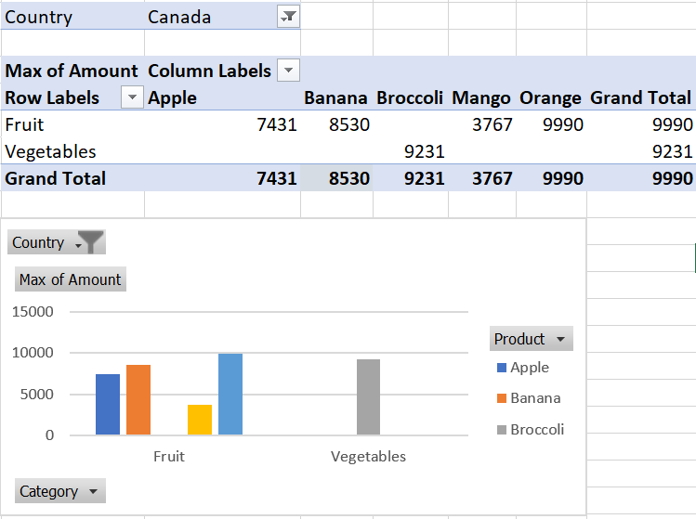
- Use the Category filter to only show the vegetables exported to each country.

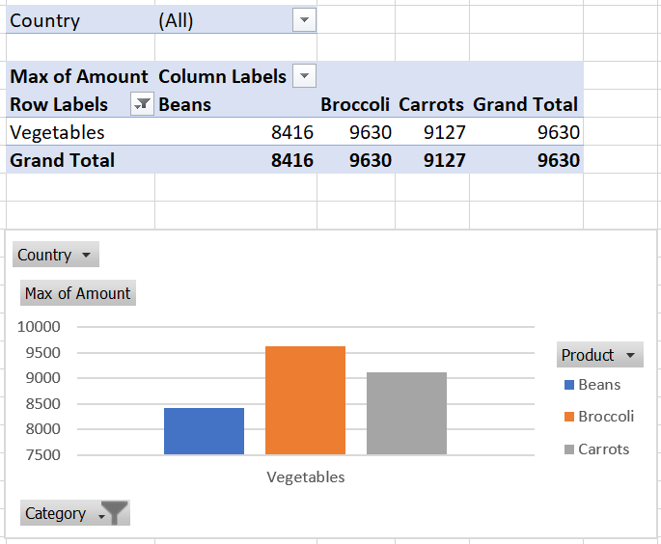

Task No 03: Perform the number system conversion on any number of your choice with the help of formulae provided by Excel.
